Viswam Engineering College,
Madanapalle – 517325

ALUMNI MEET REPORT - 2025

‘The Alumni Meet: a celebration of our past and a toast to our future.’

Date: 15th February 2025
Venue: Viswam Engineering College Conference Hall.
Organized for: B.Tech, M.Tech, and MBA Students
Chief Guest: Ms. A. Sheetal, Strategic Consultant - IBM Bangalore
Dignitaries Present:
- Shri M. Prabhakar Reddy, Chairman, Viswam Engineering College
- Dr. D. Ramana Reddy, Principal
- Dr. B. Sankar Naik, Dean - Alumni Affairs
- Faculty members and distinguished alumni

Introduction
Viswam Engineering College successfully conducted a 9th Alumni Meet on 15th February 2025. The event aimed to reconnect alumni with their alma mater, provide networking opportunities, and offer current students valuable insights into career paths, industry trends, and professional experiences. The meet witnessed the enthusiastic participation of alumni from various graduating batches, faculty members, and current students.
The Alumni Association of Viswam Engineering College organized "ALUMNI MEET 2025"- a programme to facilitate, consolidate and coordinate Alumni Activities at VEC Conference Hall in Block - B on 15th Feb 2025. The alumni meet is to reconnect with the Alumni and celebrate their success and various achievements. The Alumni started arriving in college by 9.00 a.m. and they were received by the registration team and they have been asked to fill the registration form. The event began with lighting of the lamp & invoking the blessings of Goddess Saraswati. The Alumni Meet started with a welcome address by the alumni association Dean Dr. Sankar Naik. B. accorded a warm welcome to all and the meeting was graced by the Principal Dr. D. Ramana Reddy appraised the alumni about the College’s changing infrastructure, and proactive measures taken in recent times for the welfare of students and also Chairman Shri M.Prabhakar Reddy and Chief Guest A.Sheetal, Strategic Consultant, Bangalore addressed the gathering.
It was a day filled with excitement, emotions, and nostalgia as the alumni, both recent and older, came together to relive their school days and connect with their old classmates and teachers.
The meet was attended by around 107 alumni from all over the country, ranging from those who graduated a few years ago to those who graduated more than a decade ago. The registration process was smooth and hassle-free, and the alumni were given a warm welcome by the organizing committee.

Event Highlights
The Alumni Meet featured engaging discussions and interactive sessions, allowing former students to share their experiences and mentor the current batch.
- Welcome Address
  - Dr. B. Sankar Naik , Dean Alumni Affairs, welcomed the alumni and dignitaries.
  - Dr. D. Ramana Reddy, Principal, shared recent achievements and developments of the college.
  - Shri M. Prabhakar Reddy, Chairman, welcomed the alumni and Interacted with all of them.
- Chief Guest Speech
  - Ms. A. Sheetal, Strategic Consultant - IBM Bangalore, delivered an inspiring keynote address on industry advancements, career opportunities, and the evolving technological landscape.
- Alumni Sharing Sessions
  - Alumni from different industries shared their career journeys, challenges, and successes.
  - Discussions on industry trends, skill development, and job market expectations.
- Panel Discussion and Q&A
  - A panel of distinguished alumni engaged in a discussion on career growth and entrepreneurship.
  - Current students had the opportunity to ask questions about career paths and higher education options.
- Networking and Interaction
  - Alumni and students interacted informally, building professional connections.
  - Opportunities for mentorship and internship guidance were explored.
- Cultural and Entertainment Segment
  - The event concluded with cultural performances, fun activities, and a vote of thanks by Dr. B. Sankar Naik, Dean - Alumni Affairs.

Key Takeaways
- Strengthening alumni relations and fostering a sense of belonging.
- Providing students with real-world insights and career guidance.
- Encouraging alumni participation in college development initiatives.
- Building a strong professional network for students and graduates.
- Many of them were seen clicking photographs with their former classmates and teachers, capturing the memories of the day.

Conclusion
The 9th Alumni Meet 2025 was a grand success, reinforcing the bond between past and present students. It provided a platform for knowledge sharing, networking, and mentorship. Viswam Engineering College looks forward to organizing more such events to nurture lifelong connections and professional growth. The event was not only a celebration of the college's legacy, but it was also an opportunity for the alumni to network and to give back to the college in various ways. The event ended with a promise to meet again next year, for a yet another successful Alumni Meet.

Invitation and Welcome Banners
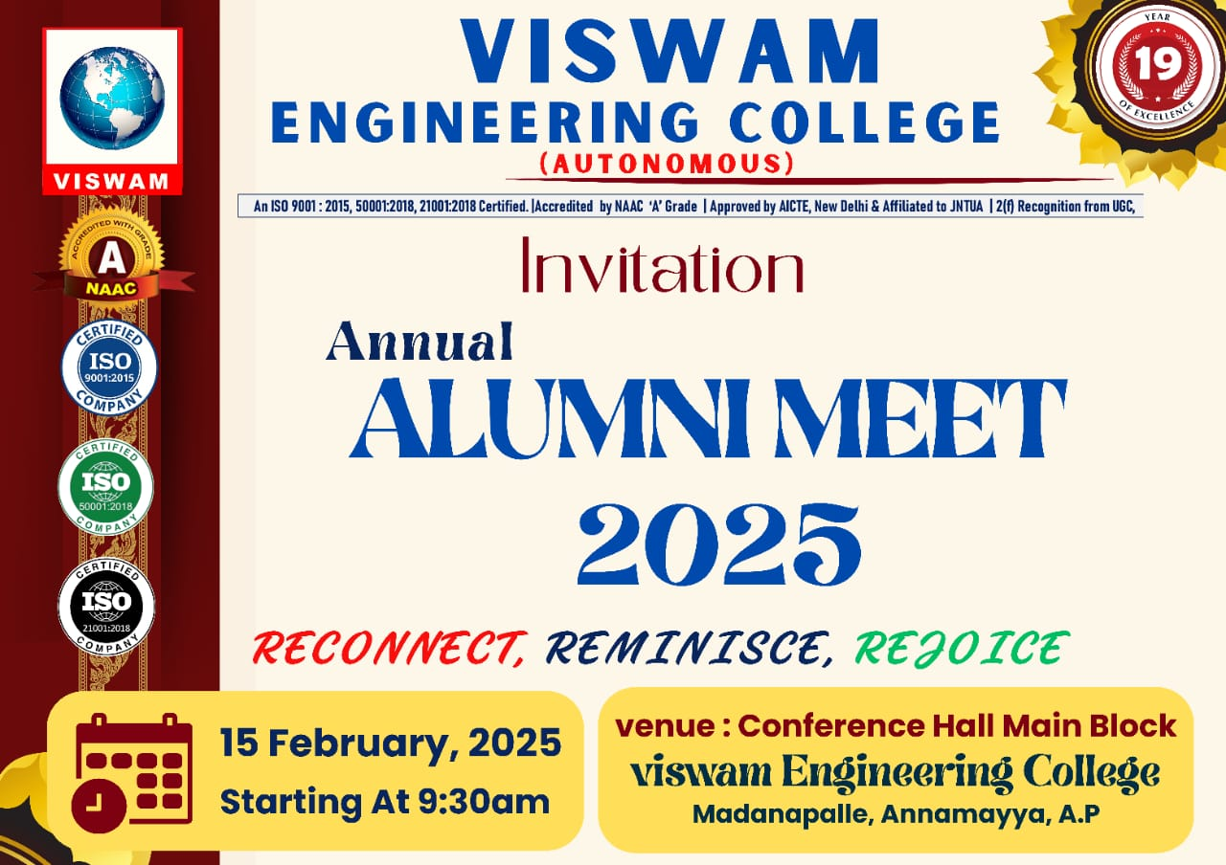
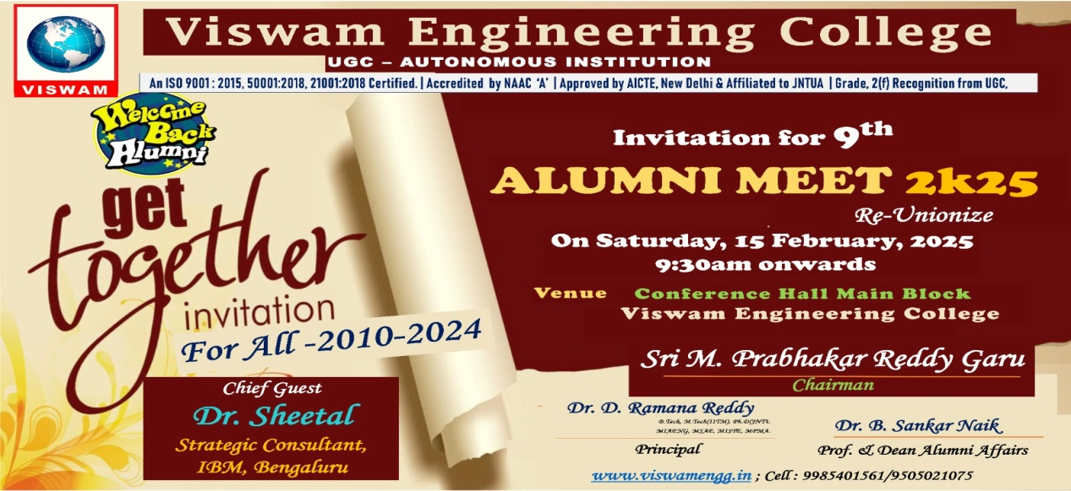
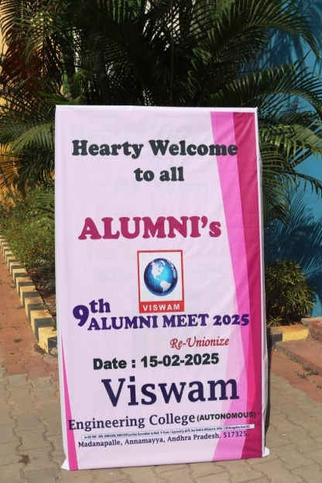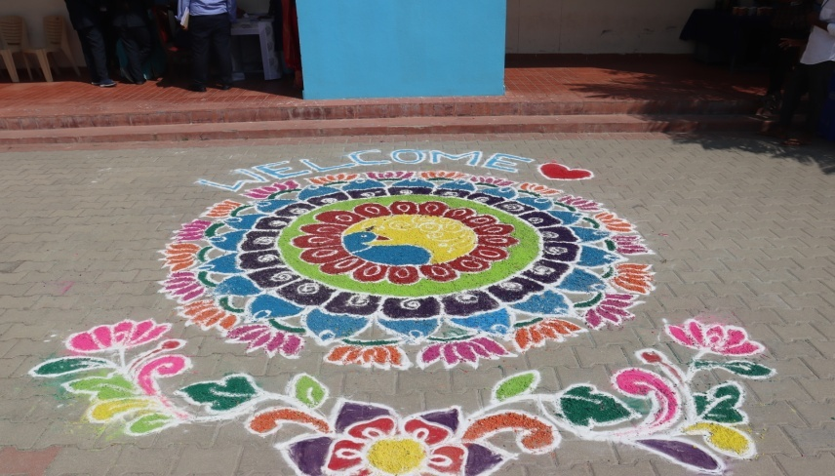

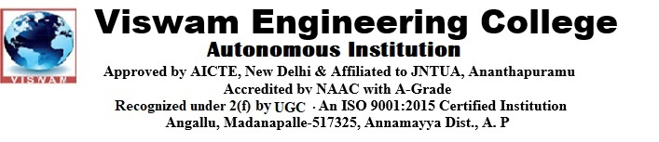
9th ALUMNI MEET 2K25
Date: 15-02-2025(Saturday) Time: 9.30AM Venue: Conference Hall, VEC Campus.
Attendees: Chief Guest, Chairman, Principal, Deans, HODs, Staff, Alumni.
10.00 AM | - Welcome and Introduction:  Welcome address by the student representative.  Brief introduction of the "Alumni” association and its objectives.
10.10 AM | - Lightening of the Lamp  Traditional lamp lighting ceremony by dignitaries to symbolize the commencement of the association's activities and prayer song.
10.15 AM | - Classical dance performance by Student
10.25 AM | - Inaugural Address by Dean Alumni Affairs  Dean Alumni Affairs addresses the gathering, highlighting the importance of the Association and its objectives.
10.35 AM | - Address by Principal  Principal shares his vision for the association and emphasizes its role in the overall development of students and college initiatives.
10:40 AM | - Chief Guest Speech  Chief guest delivers an inspiring speech.
11.00 AM | - Distinguished Alumni’s Perspectives  Selected Distinguished Alumni (2-3) share their experiences, insights, and suggestions., and what they hope to achieve through the association.
11.20 AM | - Alumni Interaction Session  Moderated discussion focusing on career development, industry trends, college initiatives.
11.40 AM | - Cultural Events
12.40 PM | - Chairman sir Speech
1.20 PM | - Memento distribution  Presentation of mementos to Alumni
1.20 PM | - Felicitation and Token of Appreciation  Token of appreciation presented to the Chief Guest.
- Vote of Thanks
Vote of thanks by Acknowledging the contributions of everyone involved
Registration
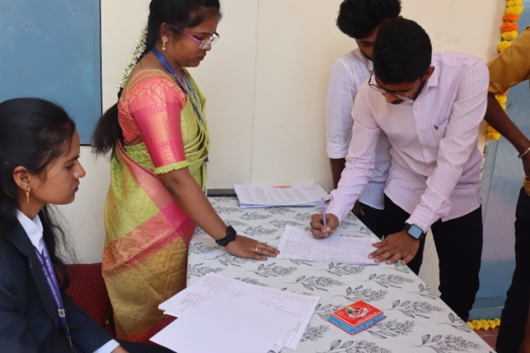 | 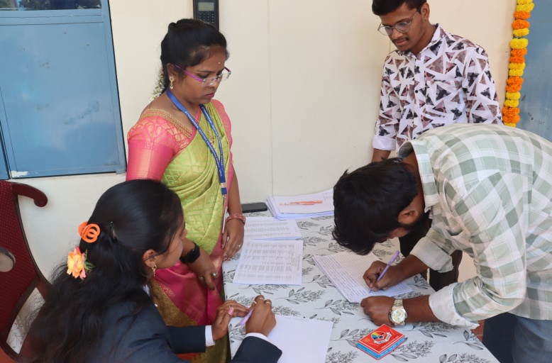
The Alumni started arriving in college by 09.00 a.m. and they were received by the registration team and were taken on a campus tour where they visited the familiar place where they had studied and were shown the various developments that had taken place since then. It was a day filled with excitement, emotions, and nostalgia as the alumni, both recent and older, came together to relive their college days and connect with their old classmates and Faculty Member.
Greeting the Guest and Alumni:
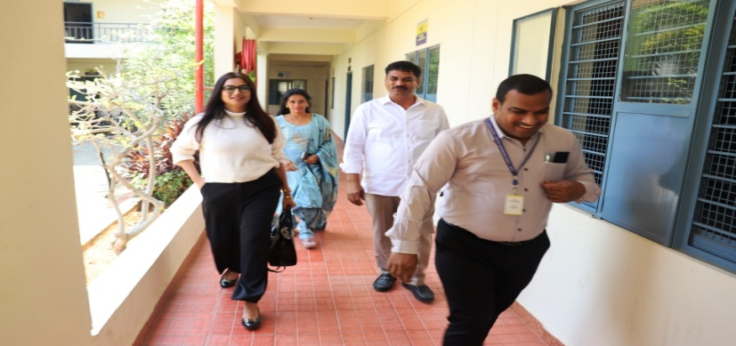

Start of Function:
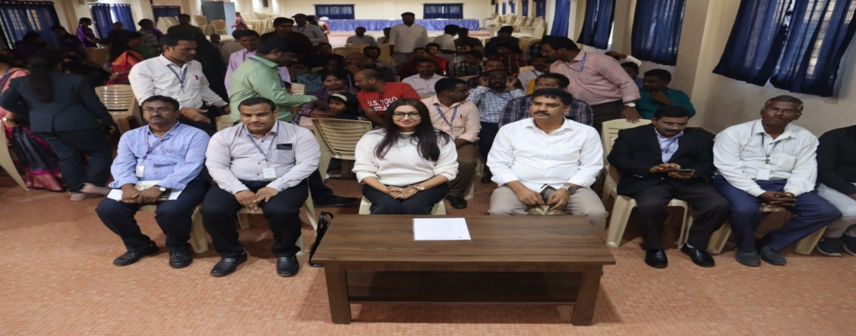
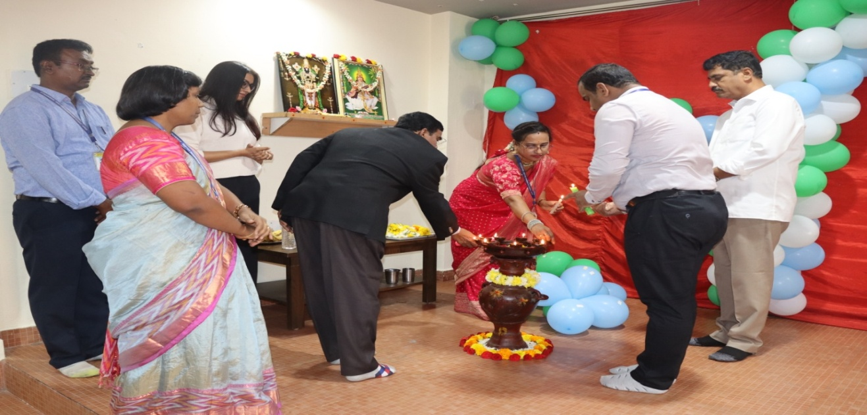

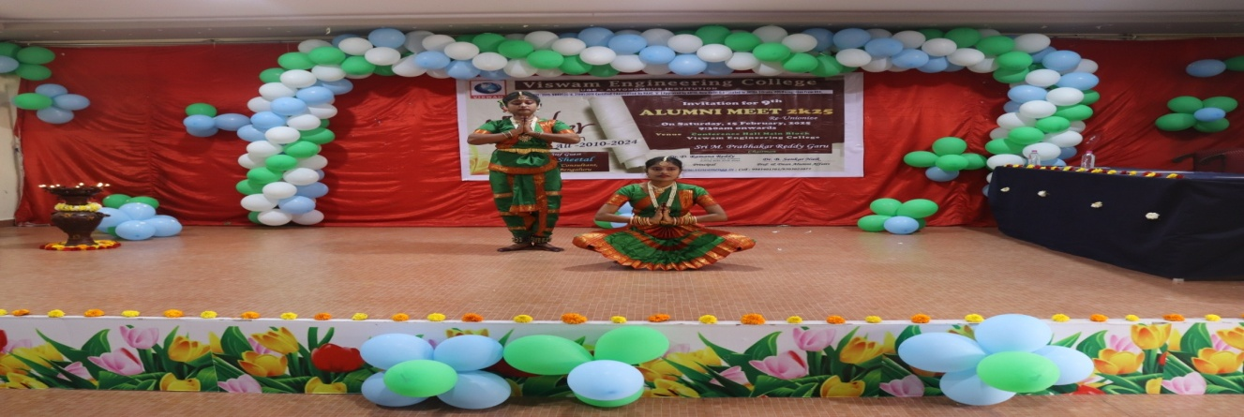
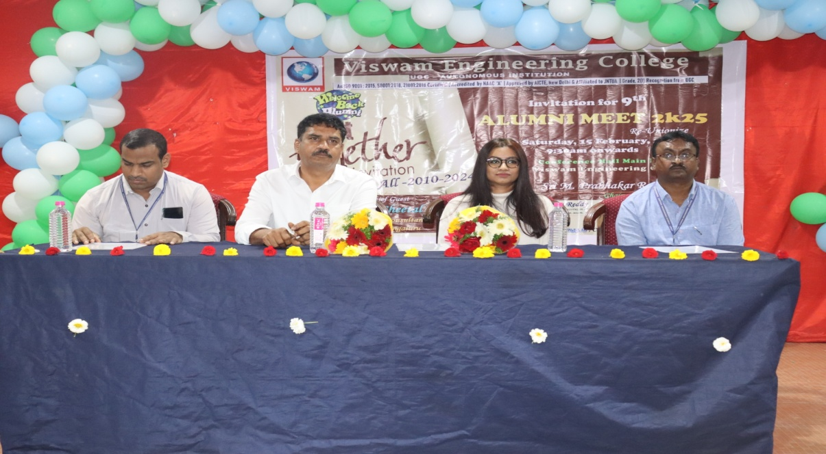
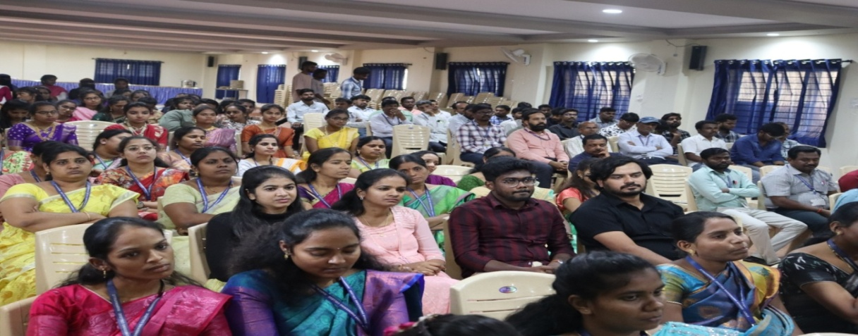
The meet was attended by around 107 alumni from all over the country, ranging from those who graduated a few years ago to those who graduated more than a decade ago. The registration process was smooth and hassle-free, and the alumni were given a warm welcome by the organizing committee.

Address by Chief Guest, Chairman Sir, Principal Sir.

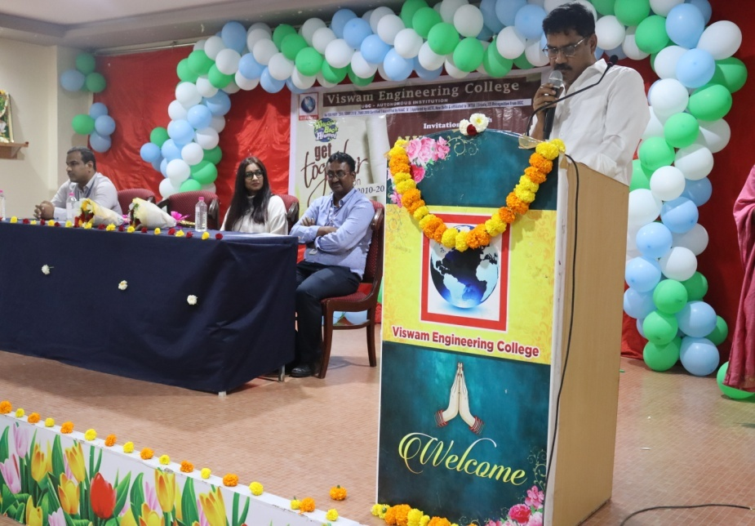

Alumni Thoughts & Interaction with gathering

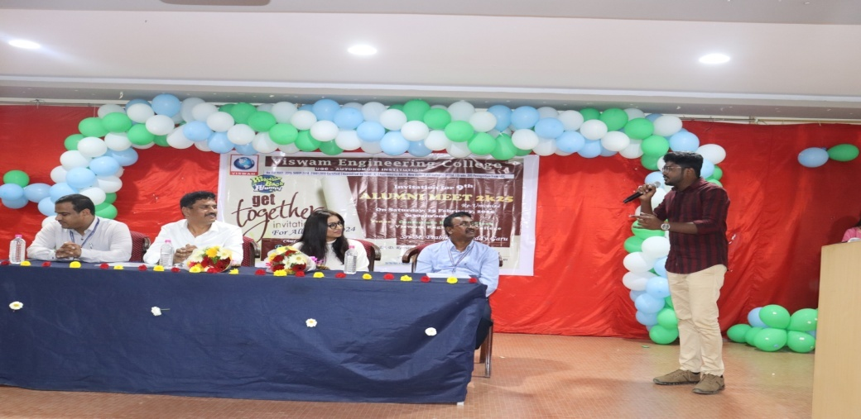
Our Alumni Mr. Prathap Reddy. C, Currently working as AI MVP Developer in Microsoft, Bangalore. His has remembered college memories with Chairman Sir and assured campus placements assistance to the outgoing students.
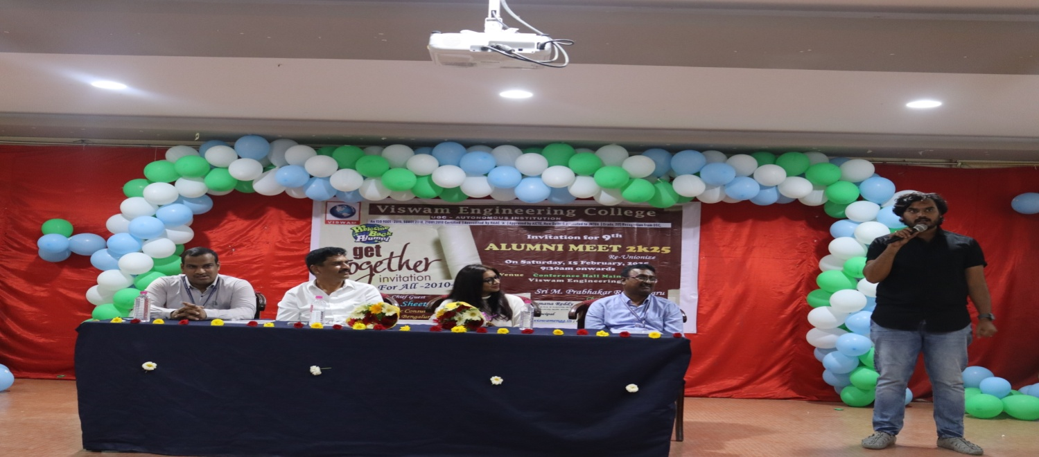
Our Alumni Mr. S.M Ashraf, Currently working as HR Consultant - Capgemini, Bangalore. He has remembered college memories with Chairman Sir and planned a training programme for B.Tech and Post Graduate students.

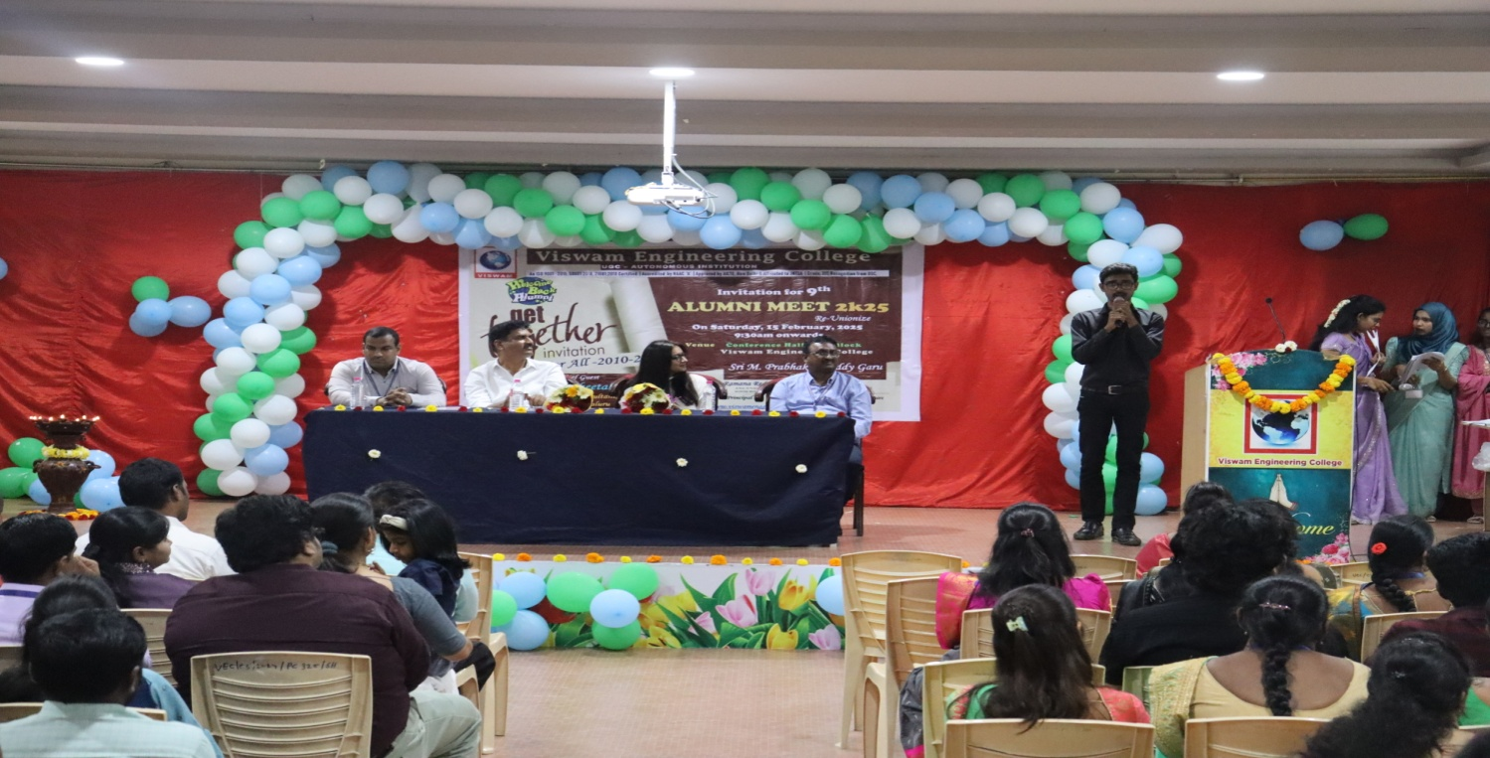
Our Alumni Mr. Mubarak, Currently working as HR Executive at SBL Knowledge Services Pvt. Ltd, Bangalore. His has remembered college memories with all and he expressed his positive response to connect reputed companies for placements.
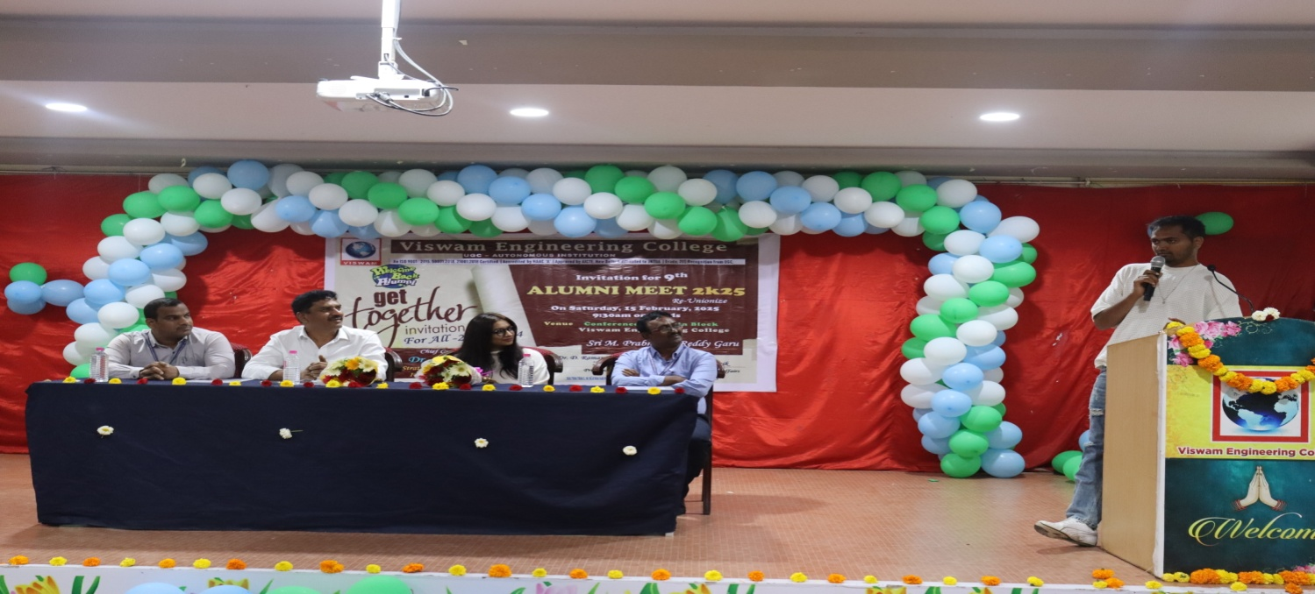
Our Alumni Mr. S. Thippa Reddy, Currently working as Researcher in USA. He has remembered college memories with all.

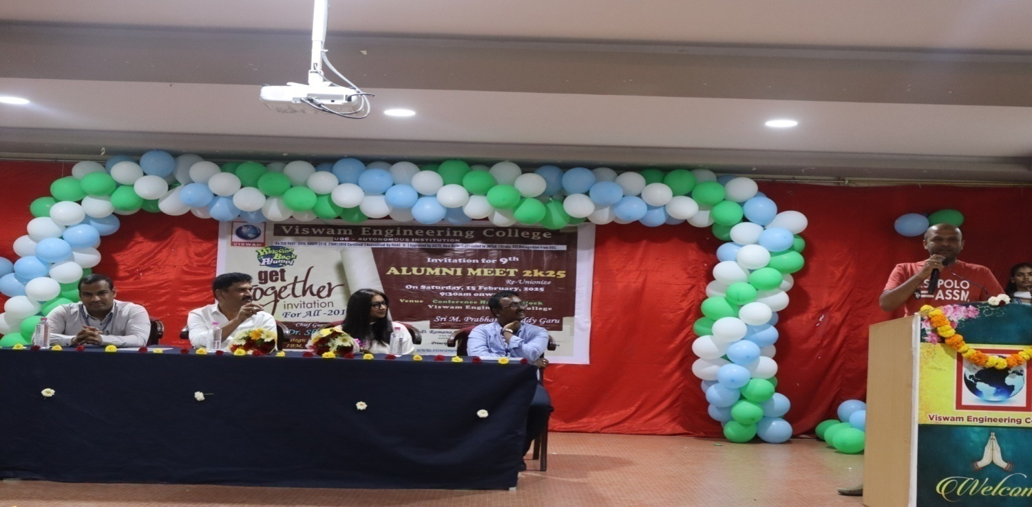
Our Alumni Mr. Mosheen Basha, Currently working as HR Manager in Google, Bangalore. He has remembered college memories with all and supported the training initiatives to improve students’ skillset in technical and managerial areas.

Cultural Program
Performed by B.Tech Students.

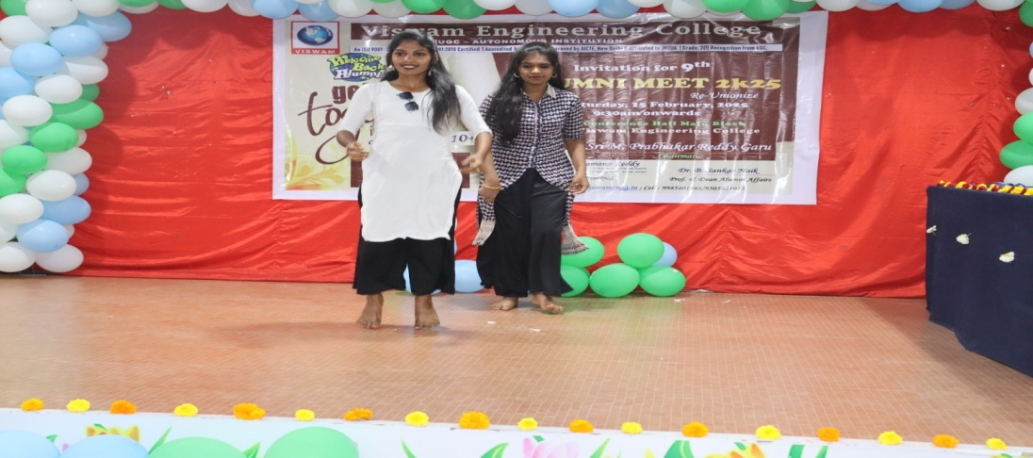
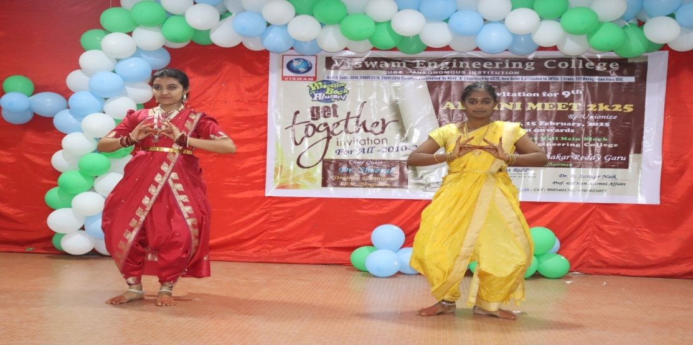
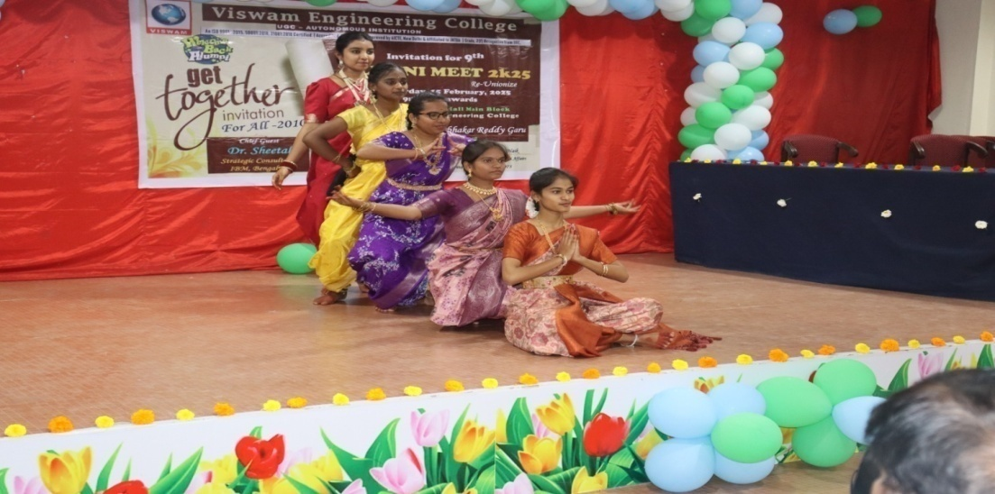
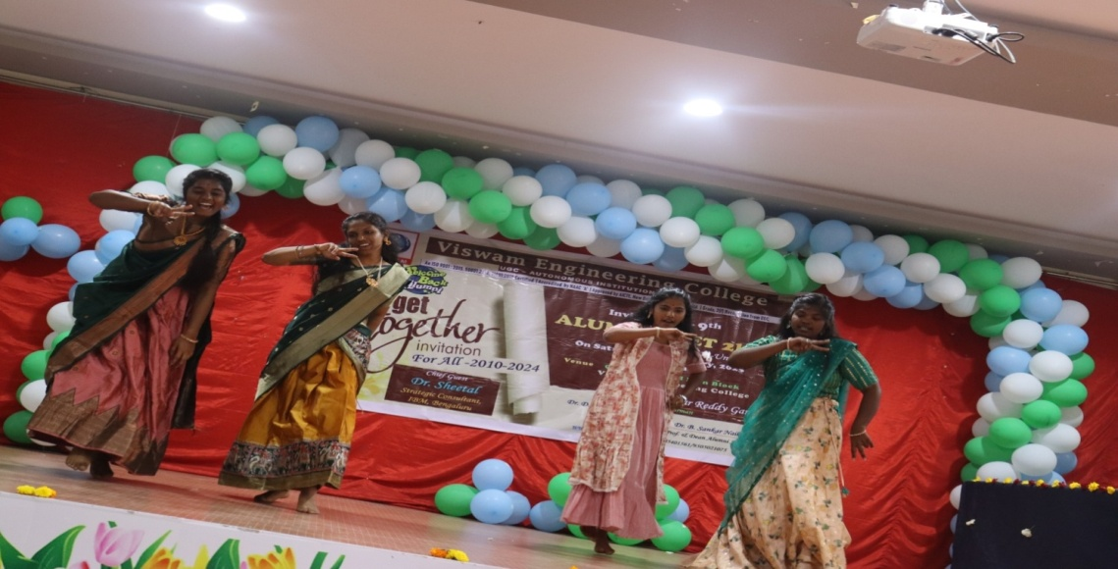

Group Photo
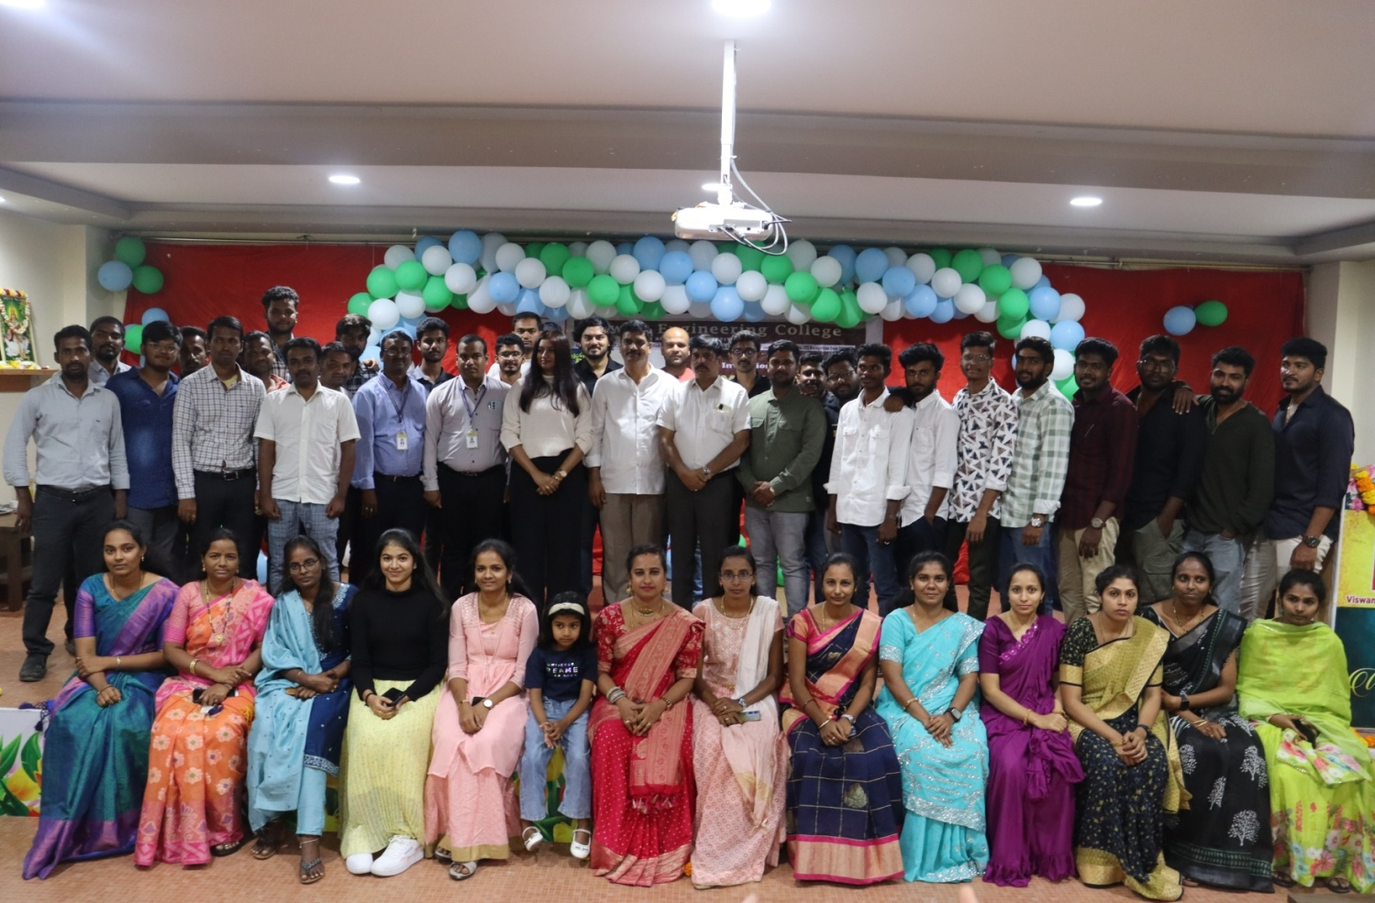
SOME GLIMPSES OF THE EVENT:
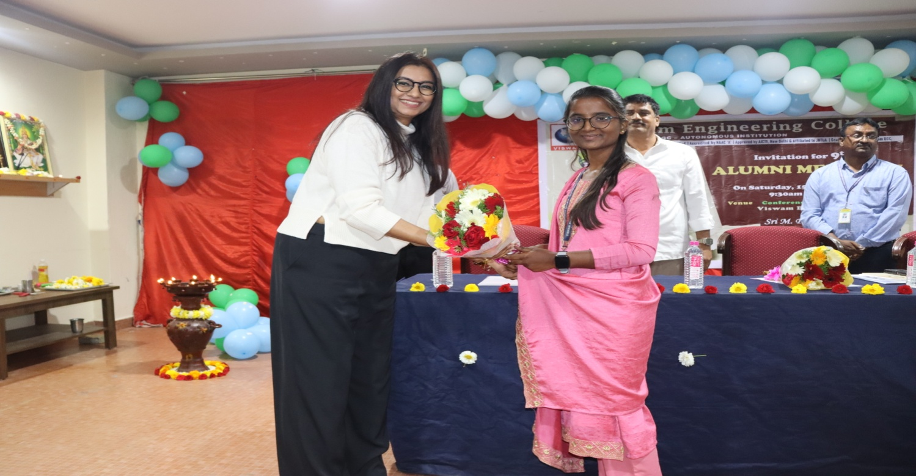

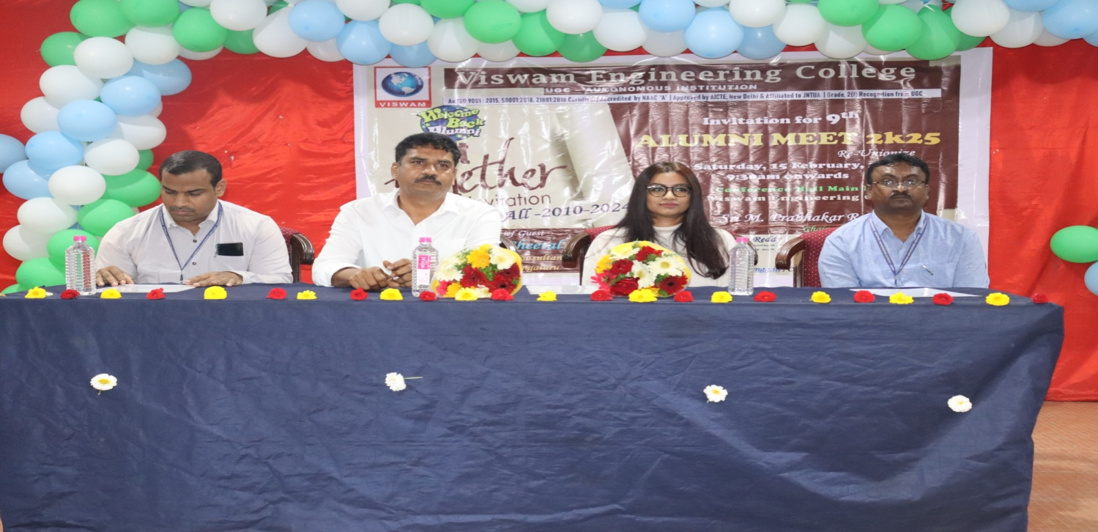

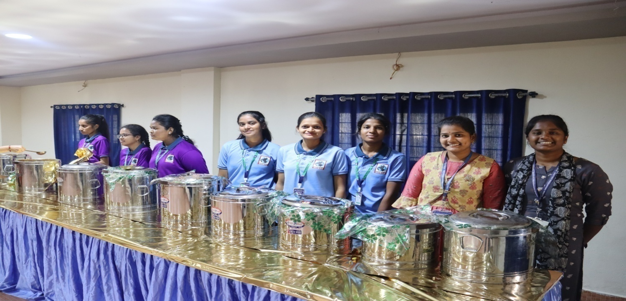

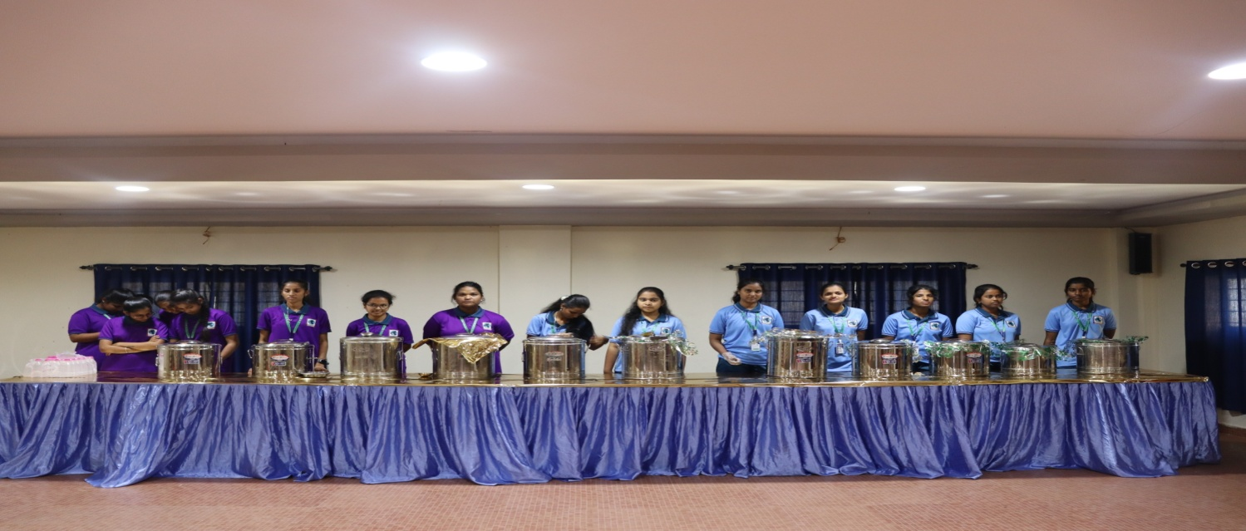

Media Coverage
